**GENERAL KNOWLEDGE LESSON GUIDE**

**FOR TOP CLASS TERM ONE 2023**

**WEEK I ORIENTATION**

**Lesson 1**

-Singing songs

-learning toilets habits

-Good eating habits

**Lesson 2**

-Asking for permission

(Excuse me, ………May I ….)

-Saying sorry, thank you ……….

-Sharing

**Lesson 3**

-Greeting (Good morning)

-Learning our names(teachers & learners)

**Lesson 4**

-Telling our age - ( I am 5 years old)

-Knowing our sex - ( I am a girl / boy)

**Lesson 5**

-Telling our class. (I am in ……… class)

Telling where we live. ( I live at ……….)

**WEEK TWO**

**Lesson 1 and 2 self expression**

-Good morning …………

-My name is ………………..

-I am a ………………………..

-I am ………… years old

-I am ……………. Class

- I live at ……………

**Lesson 3**

**God’s creation**

-Talking about God and where we lives

-Oral discussion and answering questions singing songs about God.

**Lesson 4**

**Drawing and naming things God created**

e.g. People, plants , animals , insects, birds, natural lights, natural water sources, rocks , mountain, hills, stones , valleys , swamps e.t.c

**Lesson 5**

**Activity**

-Drawing and naming people God made.

-Telling their age levels and movements.

e.g. young adult youth teen old etc. Movements like crawling , walking straight , walking while blending etc

People around us

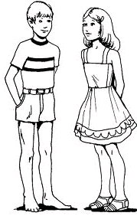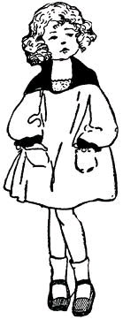

girl man woman

boy

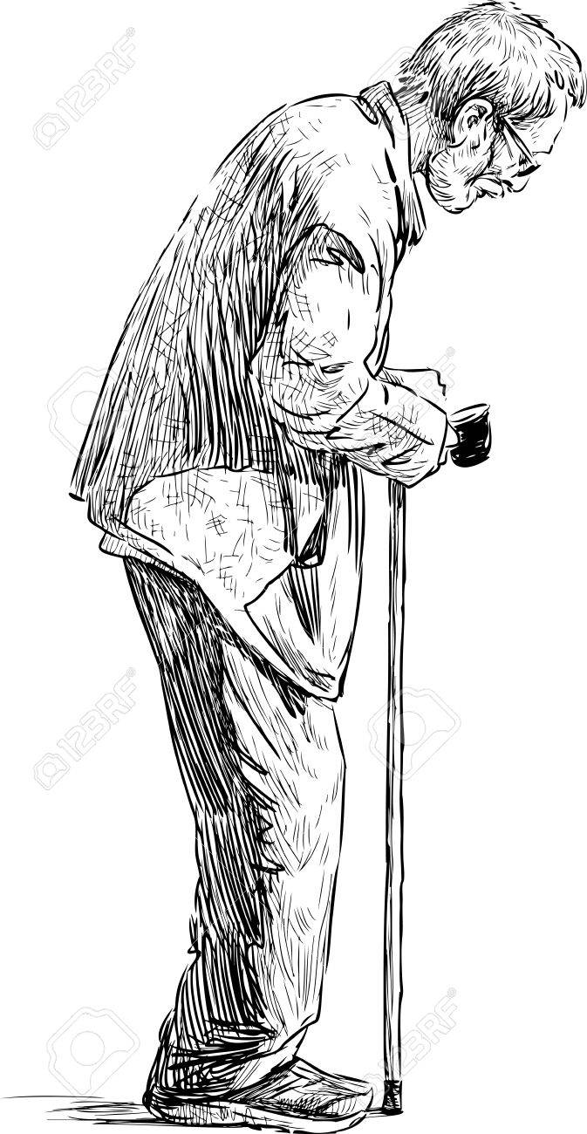

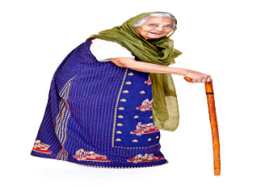

old woman old man

**WEEK THREE**

**Lesson 1**

**Activities**

-Drawing and naming.

-Blending , spelling and reading the words

Natural lights and plants God made

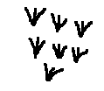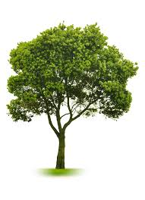

sun stars trees grass

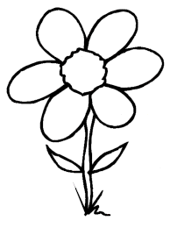

moon flowers crops that grows in the garden

**Lesson 2**

**Activity**

-Identify natural water sources.

-Blending , spelling and reading words.

-Drawing and naming the natural water sources.

Water sources and other natural things like fish, frogs etc that live in water.

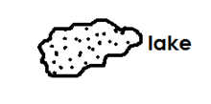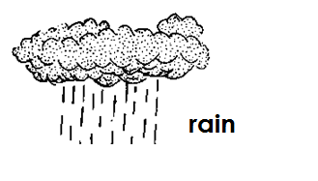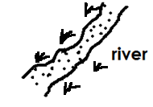

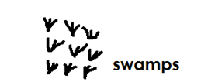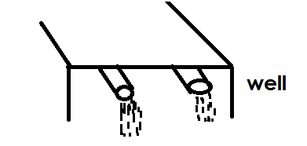

**Lesson 3**

**Activities**

-Blending , spelling and reading words

-Drawing and naming them.

Other natural things that god made.

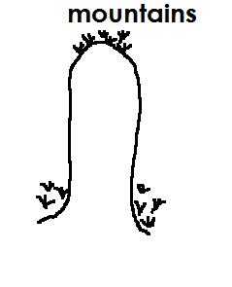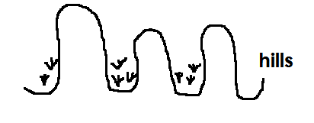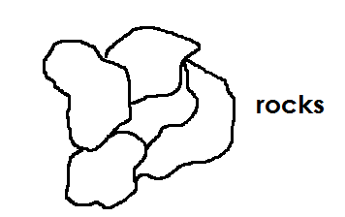

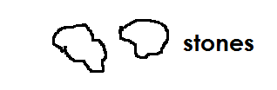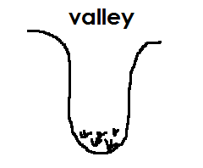

**Lesson 4**

**Activities**

-Identify the birds around us.

-Drawing and naming some of the birds.

Birds that God made

hen duck turkey eagle

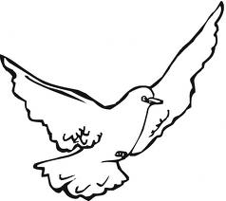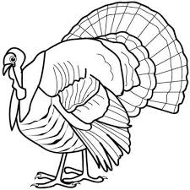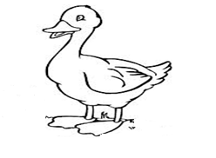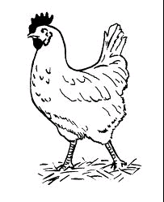

d

Owl , crested crane , parrot e.t.c

**Lesson 5**

**Activity**

-Blending and reading words.

-Drawing and naming the animals.

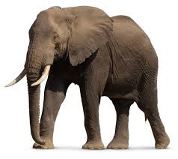donkey dog zebra elephant

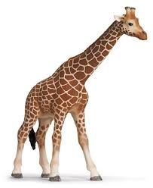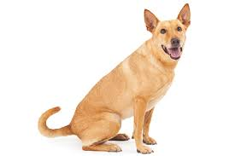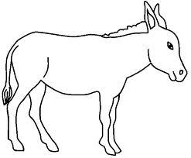

snake frog cat donkey

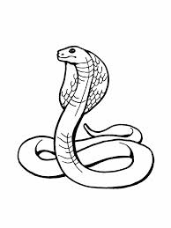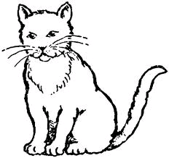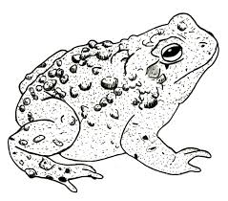

**WEEK FOUR**

LESSON 1

**Activity**

-Identifying insects around us.

-Drawing and naming.

Insects that God made

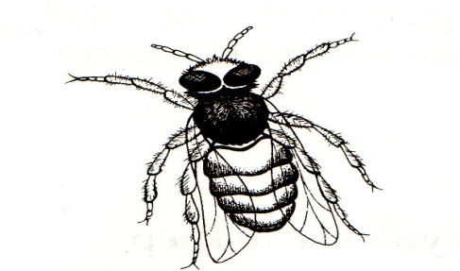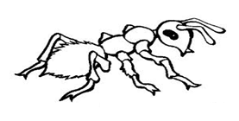butterfly bee ant grasshopper

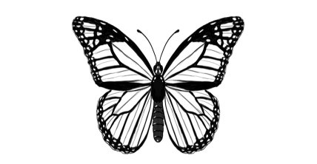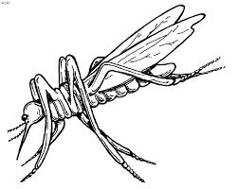

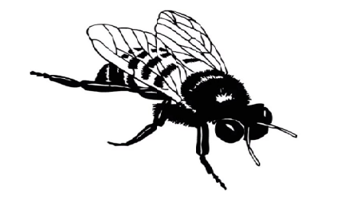housefly

mosquito wasp etc

**Lesson 2**

**Activity**

-Identifying the parts of the head.

-Drawing and naming parts of the head.

**Parts of the head**

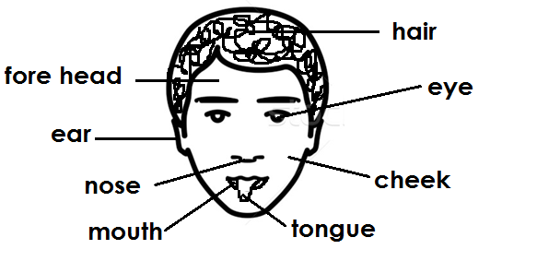

**Lesson 3**

Read and draw the parts of the head

eyes mouth nose hair

ears teeth tongue

**Lesson 4**

**Activities**

-Identifying other parts of the body like stomach, neck, shoulders, chest, breast, thigh , knees, lips.

-Navel , chin , calf , waist, palm, shin wrist, heel, back , buttocks, skin.

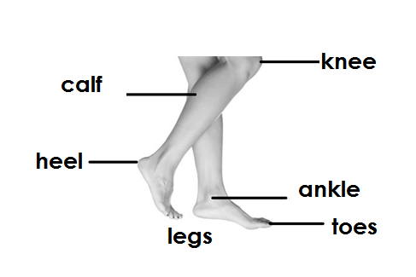Other parts of the body

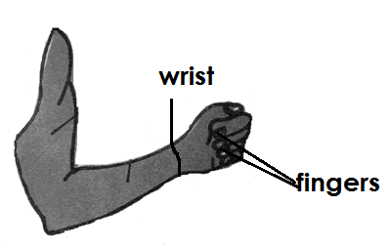

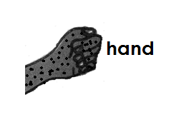 **arm**

**Lesson 5**

**Activities**

-Identify the five senses.

-Drawing and naming senses.

Answering questions

**Our senses**

-eyes to see.

-ears to hear.

-nose to smell.

-tongue to taste.

-skin to feel.

**WEEK FIVE**

LESSON 1

**Activity**

-Defining a home(A home is a place where we live or stay)

-Identifying things around the home.

-Drawing and shading our homes. bedroom store sitting room

-Telling the different rooms in house. Kitchen

Our home and the things around it.

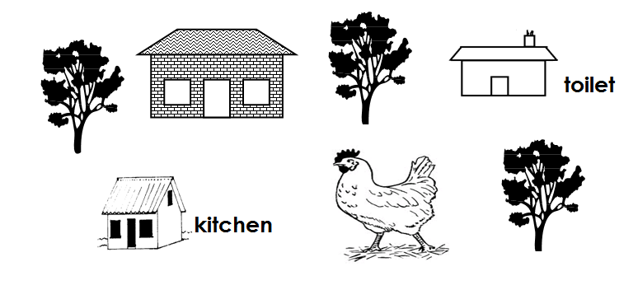

**Lesson 2**

**Activities**

-Identifying things at home and their uses.

-Drawing and naming the things found at home

**Things at home and their uses**

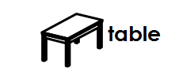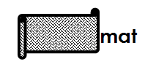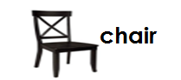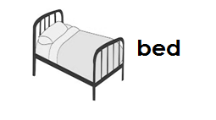

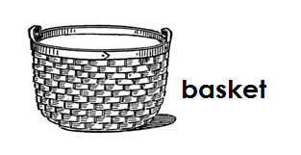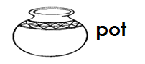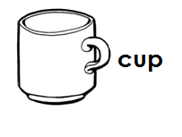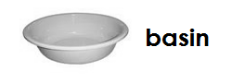

kettle , bottle , table, chair, plate , spoon, fork, knife , television , radio , cupboard, flask , stove , saucepan etc

**Lesson 3**

**Vocabulary**

chair table flask basket mat knife kettle radio plate spoon etc

**Activity**

[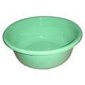](http://www.google.co.ug/imgres?imgurl=http://www.honrygroup.com/Plastic_Basin.jpg&imgrefurl=http://www.honrygroup.com/Honry-Links%20Your%20Plastic%20Materials.html&usg=__CgWEkmpZNapUSe3nQxJvTR-K8m4=&h=360&w=360&sz=15&hl=en&start=1&zoom=1&tbnid=qX99uOjvkK6thM:&tbnh=121&tbnw=121&ei=VJa2TcadOMedOtC-0JEP&prev=/search?q=plastic+basin&hl=en&sa=N&gbv=2&tbm=isch&itbs=1)Name the pictures

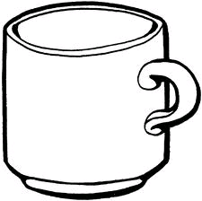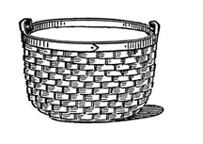



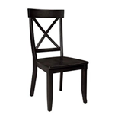

**Lesson 4**

**Activity**

-Identifying people at home

-Drawing and naming people at home

**People found at home**

sister brother father mother grandmother

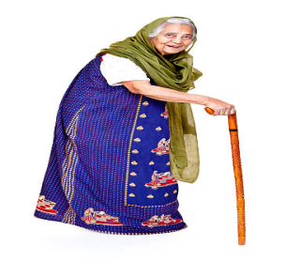

 grandfather

**Lesson 5**

Read and draw

mother sister baby

father brother grandmother

**WEEK SIX**

**LESSON 1**

-Identifying things used to clean the environment.

-Drawing and naming the things used to clean the environment

Things used to clean our homes /environment

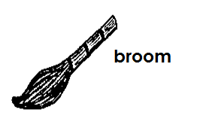

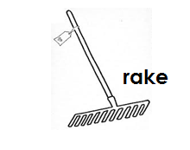

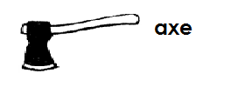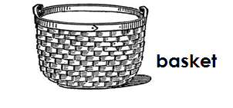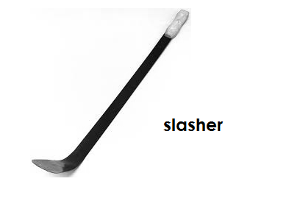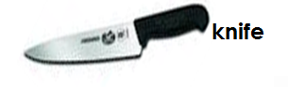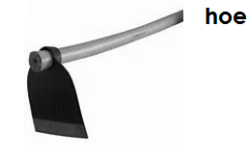

**Lesson 2**

Underline the things used to clean the environment

hoe box rake pen slasher panga plate book broom pot bed axe house knife dustbin table dustpan etc

**Lesson 3**

**Activities**

-Identifying the types of houses.

-Drawing and naming the types of houses.

Types of houses

**Activities**

-Identifying the types of houses.

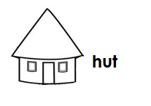-Drawing and naming the types of houses.

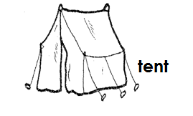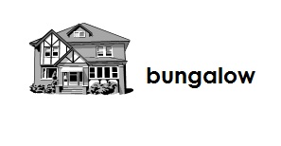

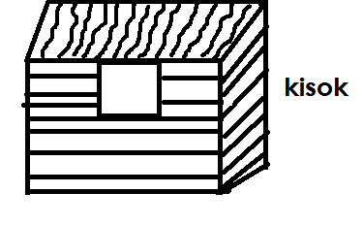

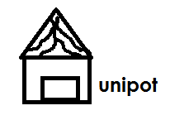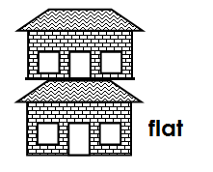

**Lesson 4**

Vocabulary

Unipot bungalow hut kiosk tent flat

**Activity**

Fill in the missing letters in the words

b ngl w hu k osk te t fl t un po

**Lesson 5**

Part of a house

**Activity**

-Identifying the parts of a house.

-Drawing and naming the parts of a house

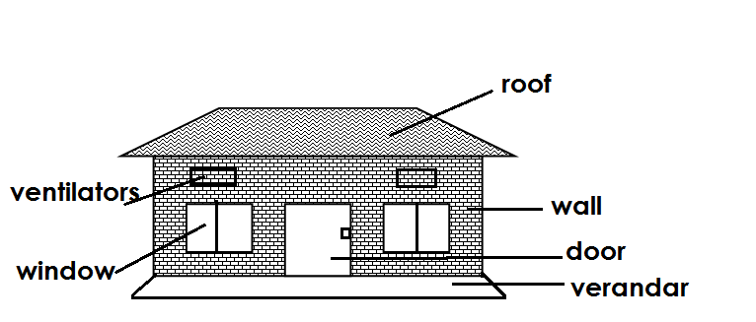

**Week seven**

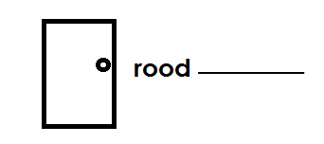**Lesson1**

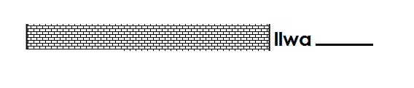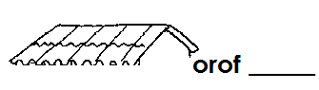

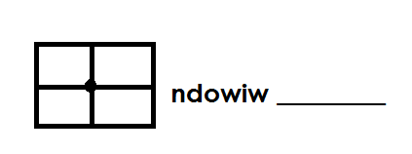

roof , wall , door , window , ventilators , verandar

**Lesson 2 and 3**

**Activities**

-Identifying the building materials .

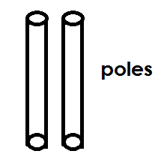**Drawing and naming the building**

-Blending , spelling and reading the words

 **Building materials**

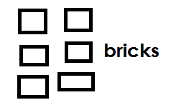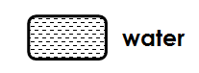



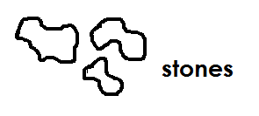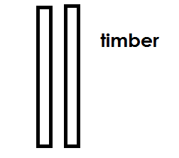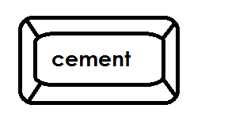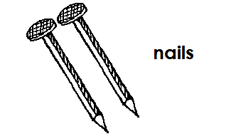

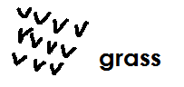

**Tick the building materials**

nail roof bricks stones hut sand house cement wall water grass

**Lesson 4**

Things used to clean the body

**Activity**

-Identifying things used to clean the body.

-Drawing and naming the things used to clean the body.

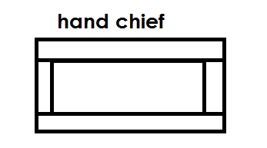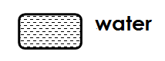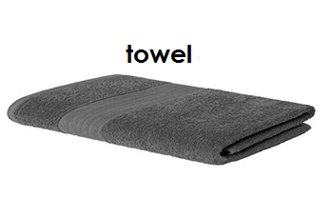

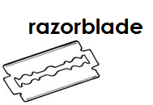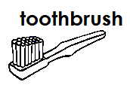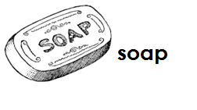

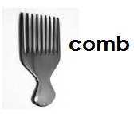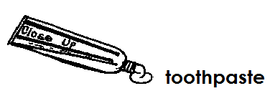

**Lesson 5**

**Vocabulary**

soap comb water towel sponge razorblade toothbrush toothpaste handkerchief ear bud toothpick etc

**Activities**

-Blending , spelling and reading words.

-Talking about ways of cleaning the body e.g. bathing , brushing, combing and treaming the hair , cutting finger nails short and toes, smearing vaseline etc

**Reading and matching same word**

soap comb

comb towel

towel soap

**WEEK EIGHT**

**LESSON 1**

**Harmful**

Dangerous things to our body

**Activities**

-Identifying dangerous/harmful things to the body.

-Drawing and naming the dangerous things.





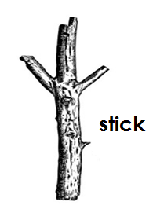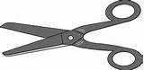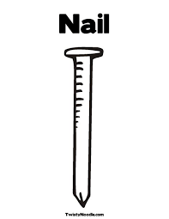

 **scissor**

**nails**

**Lesson 2**

Vocabulary

nail , broken grass, thorn, razorblade, knife ,hoe ,axe, dust, snake needle ,bone ,pang ,pin ,stone , stick , poison etc

**Activity**

-Blending spelling and reading words.

-Talking about how to keep safe and avoid accidents

-Not playing with sharp things

-Being careful etc

Circle the word for the picture

|  |  |
| --- | --- |
| https://encrypted-tbn3.gstatic.com/images?q=tbn:ANd9GcRsfscgiuNlyiuhqi5KqGR_MBkbRQNe72V5JHm_U9yTQjgdjmrVhttps://encrypted-tbn3.gstatic.com/images?q=tbn:ANd9GcRsfscgiuNlyiuhqi5KqGR_MBkbRQNe72V5JHm_U9yTQjgdjmrV | Needle nail thorn |
|  | Knife hoe snake |
|  | bone pin stick |

**Lesson 3**

Common diseases that affect our body malaria , cough , measles , flue , headache , stomach, red eye , skin rushes.

**Activity**

Oral discussion about the common diseases and the people responsible for our health like doctors, nurses , teachers , parents etc and how they do it.

**Lesson 4**

Our school and the things a round it

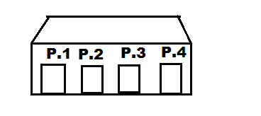

A school is a place where people go to learn.

Things around our school.

houses , trees , swings , classes , gardens , grass , flowers ,animals.

**Activities**

-Defining a school?

-Identifying things around the school.

-Drawing the school.

-Telling the offices and others places within the school compound e.g. classes, toilets , offices , kitchen , store, administration block etc

**Lesson 5**

Our school symbols

badge , uniform , school motto, signpost, s flag

**Activity oral discussion**

-Identifying things / symbols of a school.

-Answering simple questions like

* What is the colour of your uniform?
* What is your school motto?
* What can you see on the school badge etc

- Learning the school’s Vision , mission , motto and values as stated.

**WEEK NINE**

**Lesson 1**

**Activity**

Things in class

**Activity**

-Identifying things found in class.

-Drawing and naming the things in class

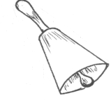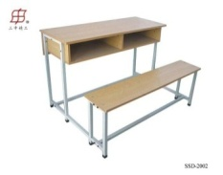

bell pencil chair bench

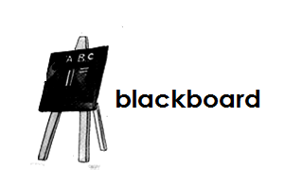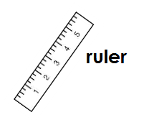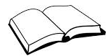

table book

**Lesson 2**

Vocabulary

2 5 8 7 8 5 1

table chair books pencil ruler pen duster

9 4

bell chalkboard etc

**Activity**

-Blending , spelling and reading words.

Read and draw for the number e.g

2 is a _____________ 5 is a __________ 10 is a ____________  
6 is a _____________ 7 is a ___________ I is a ______________

**Lesson 3**

People found at school

Headteacher , teacher, cook , cleaners, bursar, secretary, Deputyheadteacher, Director, pupils , gate keeper /Askar, nurse , driver , matrons etc

**Activities**

-Identifying people found at school.

**Matching same words**

Headteacher cook

Teacher cleaner

Cook headteacher

Cleaner teacher

**Lesson 4**

Roles of people found at school

Headteacher - heads the school

Teacher - teaches pupils

Bursar - collects school money

Secretary - types office work

Cook - cooks food

Cleaner - cleans the school compound/environment

Gatekeeper - guards the school

School nurse - treats school van

Drivers - drive school van

Director - manages the school

**Activity**

-Oral discussion about people found at school and their roles.

Read and match the person to his/ her work

Teacher cooks food

Bursar teaches pupils

Cook collects school money

**Lesson 5**

Activities done at school

reading , writing , playing , sweeping , learning , washing , eating cleaning , teaching etc

**Activity**

-Oral discussion about the activities done at school.